# **Information of Kaodim Vendor Matching for Job Requests Web Application**

* For starter, there will be a total of 24 vendors. The vendors name is taken from <https://www.kaodim.com/service-providers>.
* For database engine, I used Firebase Firestore as my primary database engine.
  + There are 2 primary collections (table) [job_requests, vendors]
  + job_requests collection consists of 5 fields
    - date_request
    - status
    - submit_location
    - user_email
    - vendor_name
  + vendors collection consists of 5 fields
    - availability
    - date_from
    - date_to
    - location
    - vendor_name
* At each month, there will be some vendors is not available during 15th to 20th. (For example, 15/5/2019 until 20/5/2019).
* For demonstration, at 1/5/2019, there will be no vendors available in only Petaling Jaya as of Labour Day.
* For the dates that vendors are not available, you can refer to the console output in Web Browser’s debugger tool.
* A confirmation email will send to the email address upon submit vendor request. Please check your inbox for the receive of email.

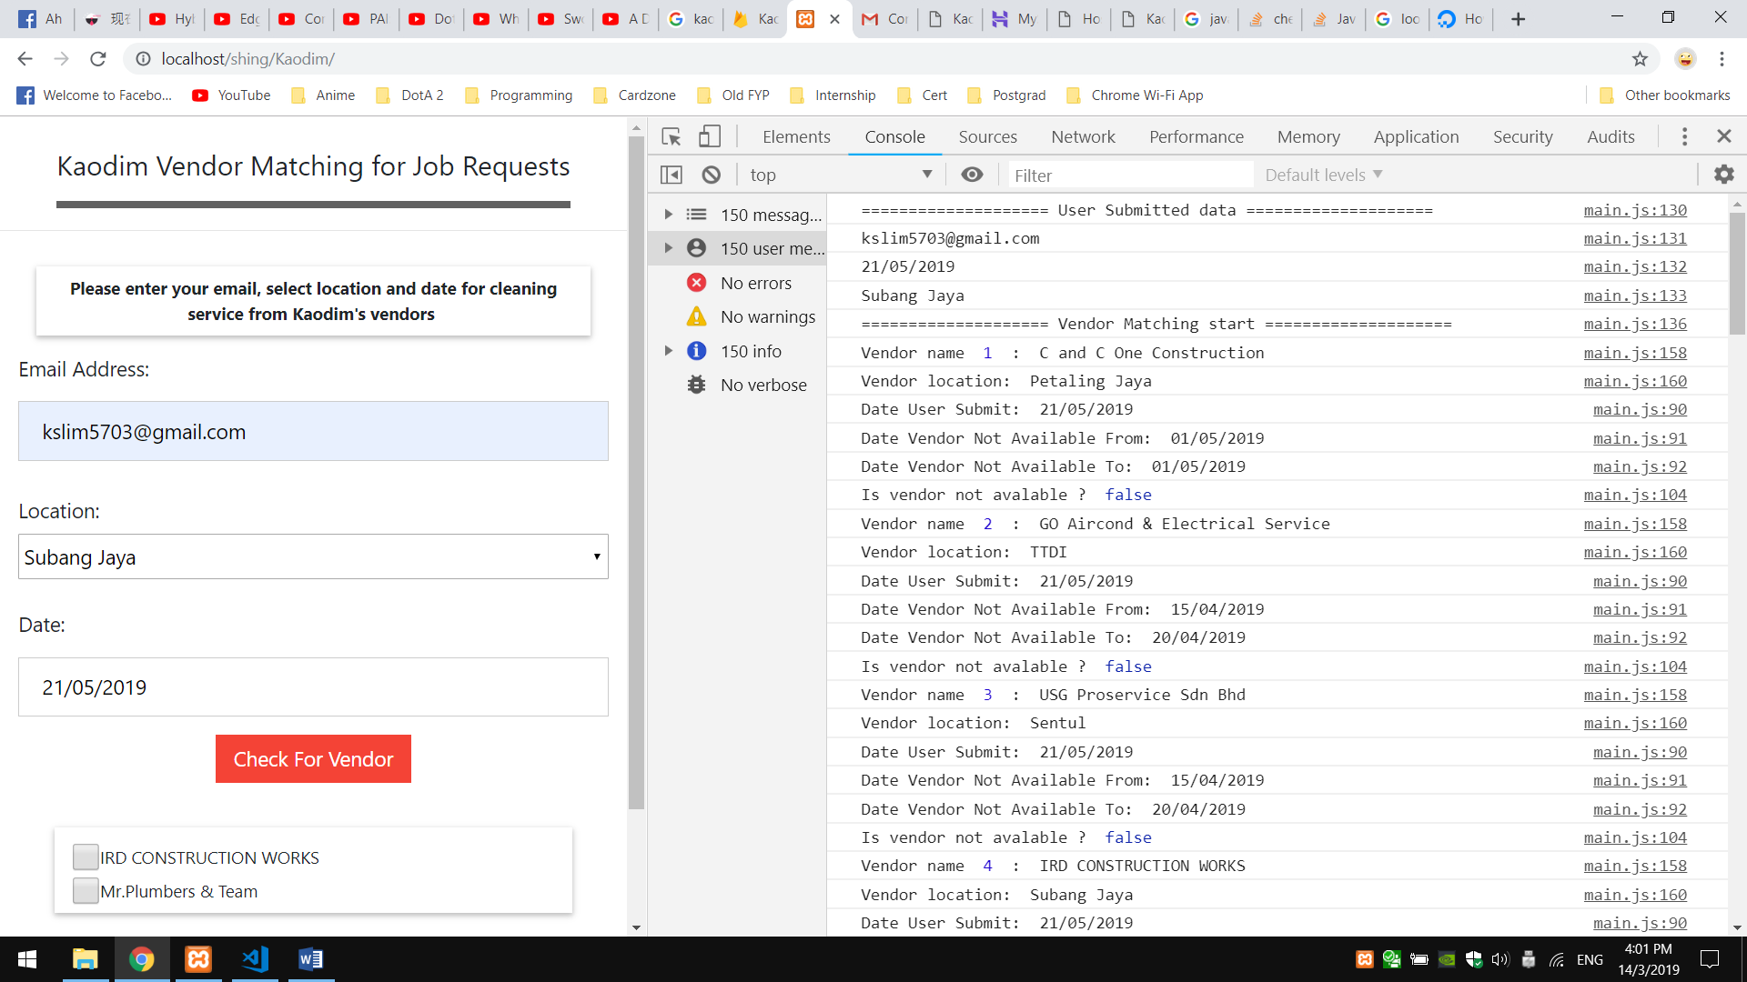

Figure 1: Browser’s console output after click <Check For Vendor> button

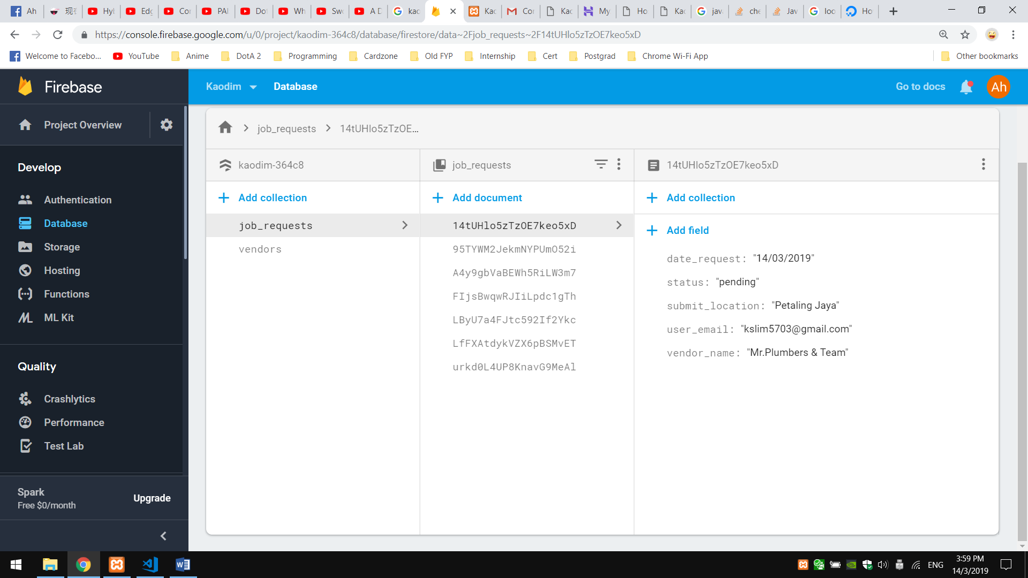

Figure 2: Job Requests collection (Job Request table)

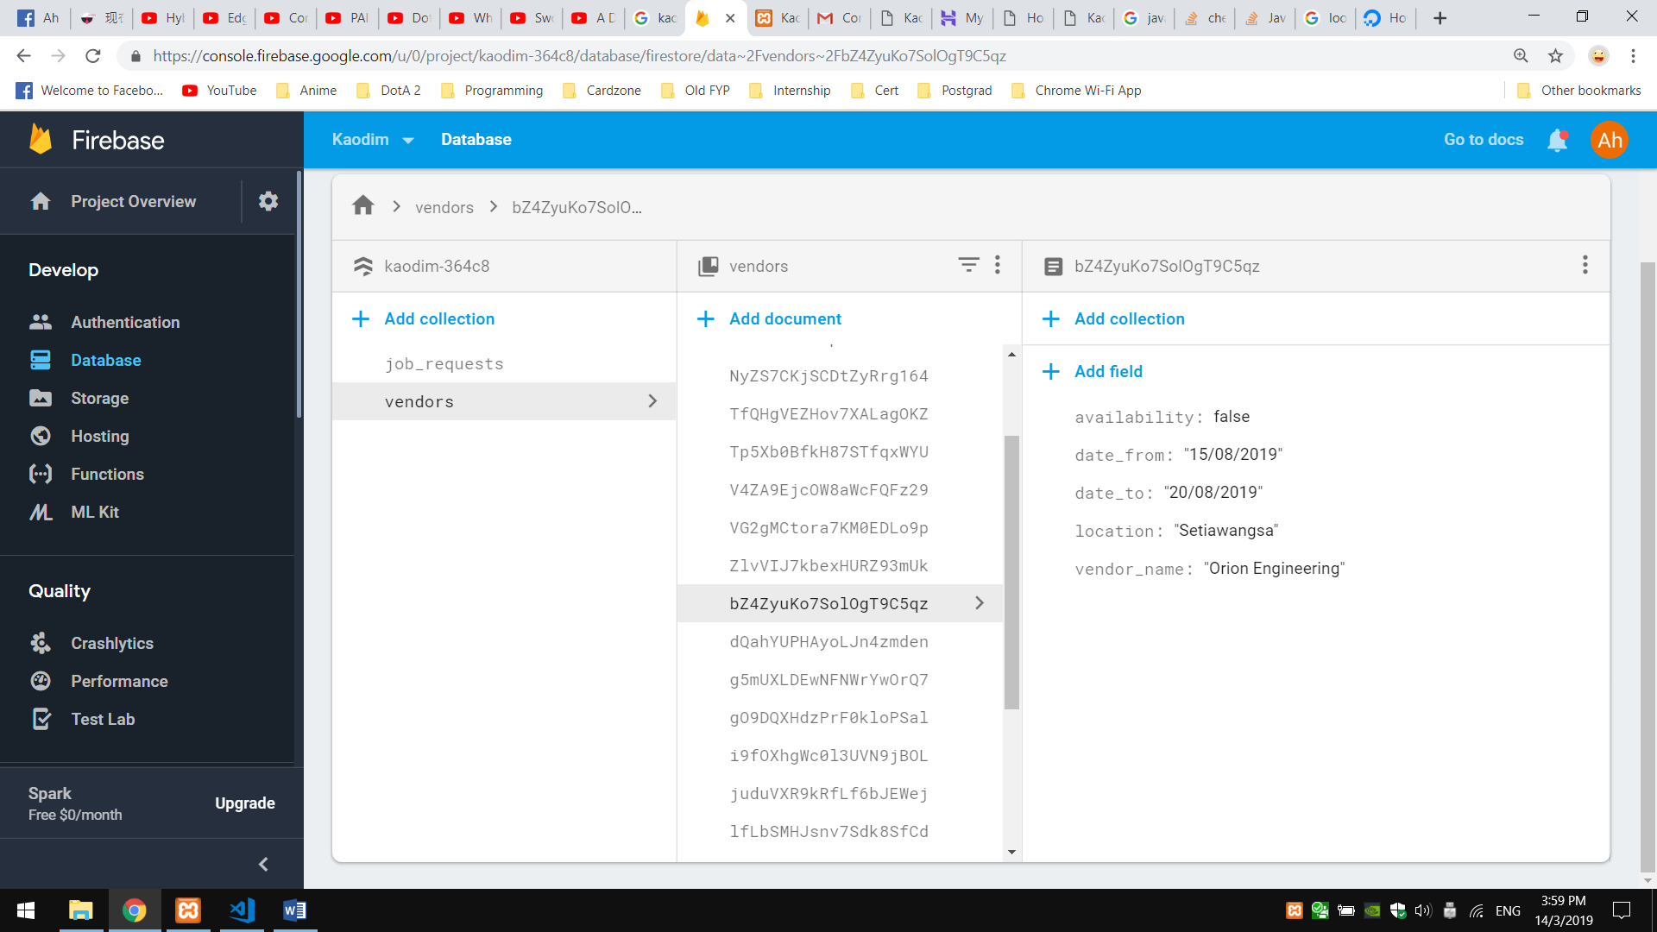

Figure 3: Vendors Collection (Vendors Table)

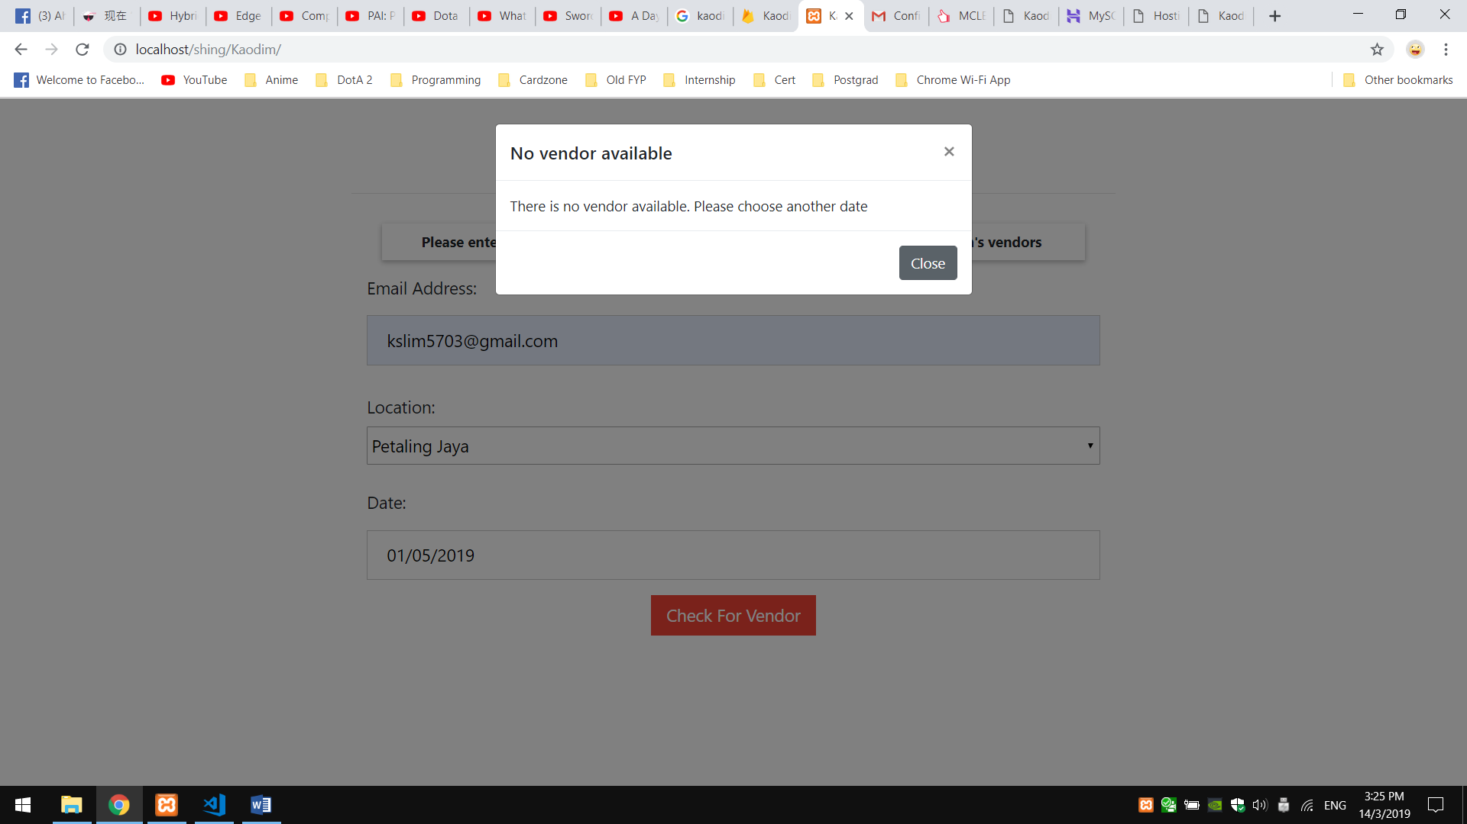

Figure 4: No vendors available in Petaling Jaya in 01/5/2019 (Labour Day)

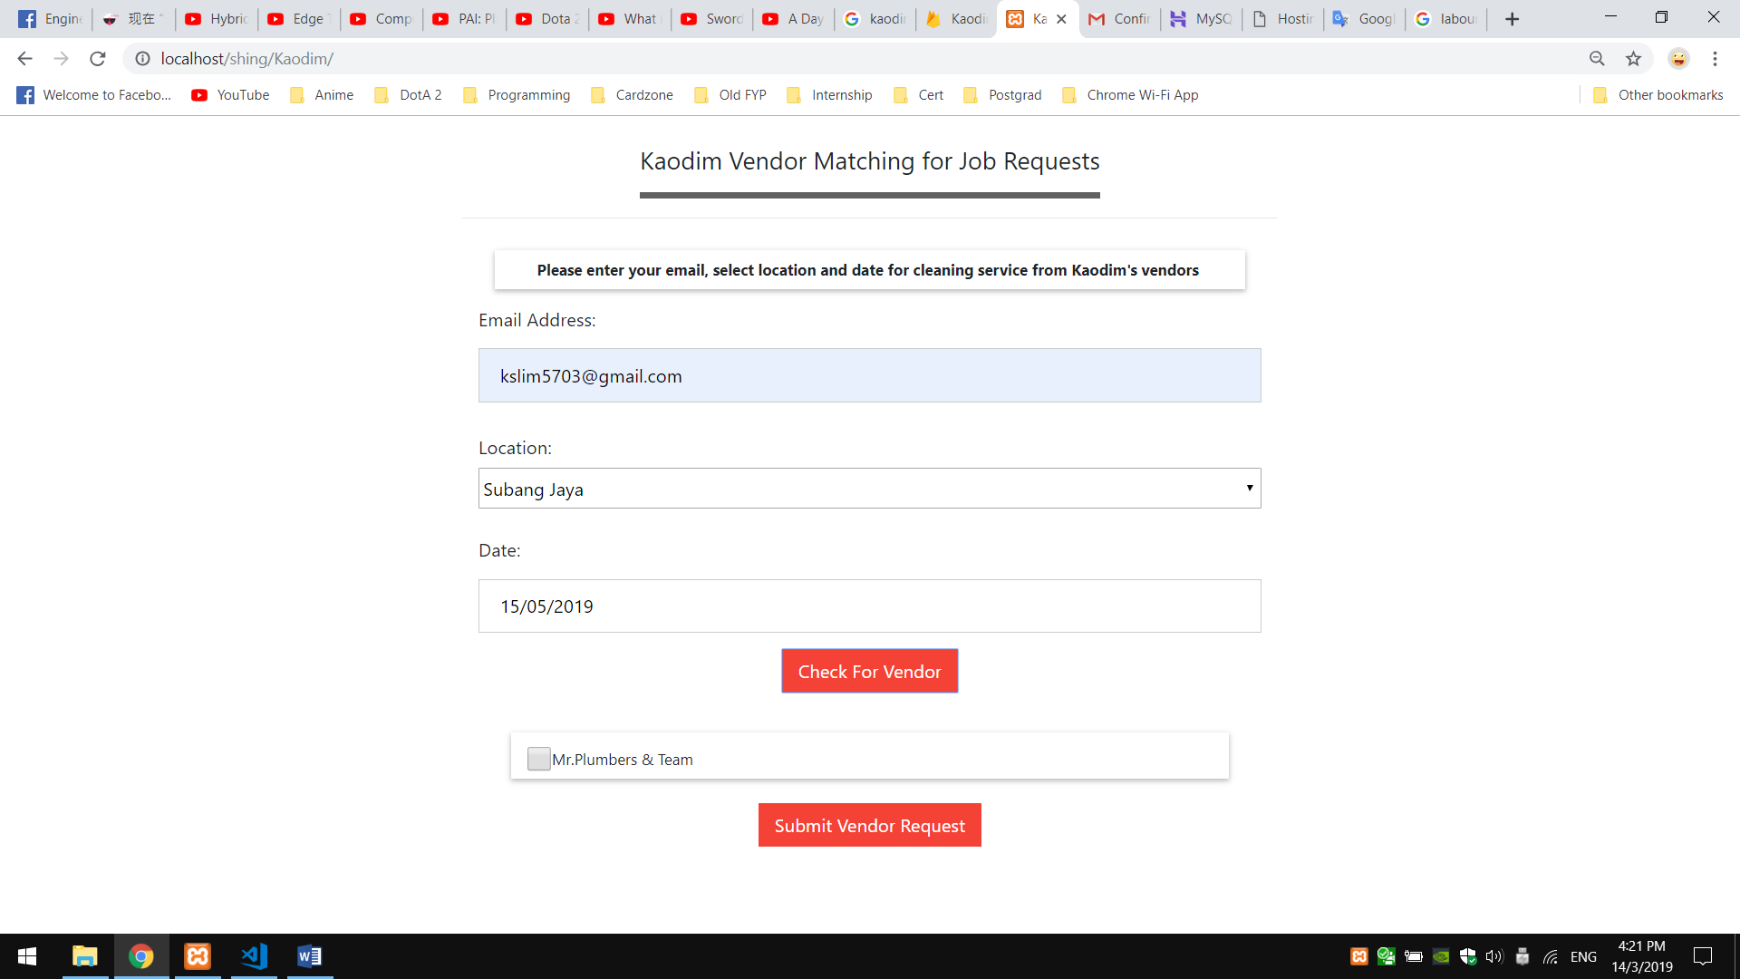

Figure 5: List of available vendors will show in below Card View after click <Check For Vendor> button

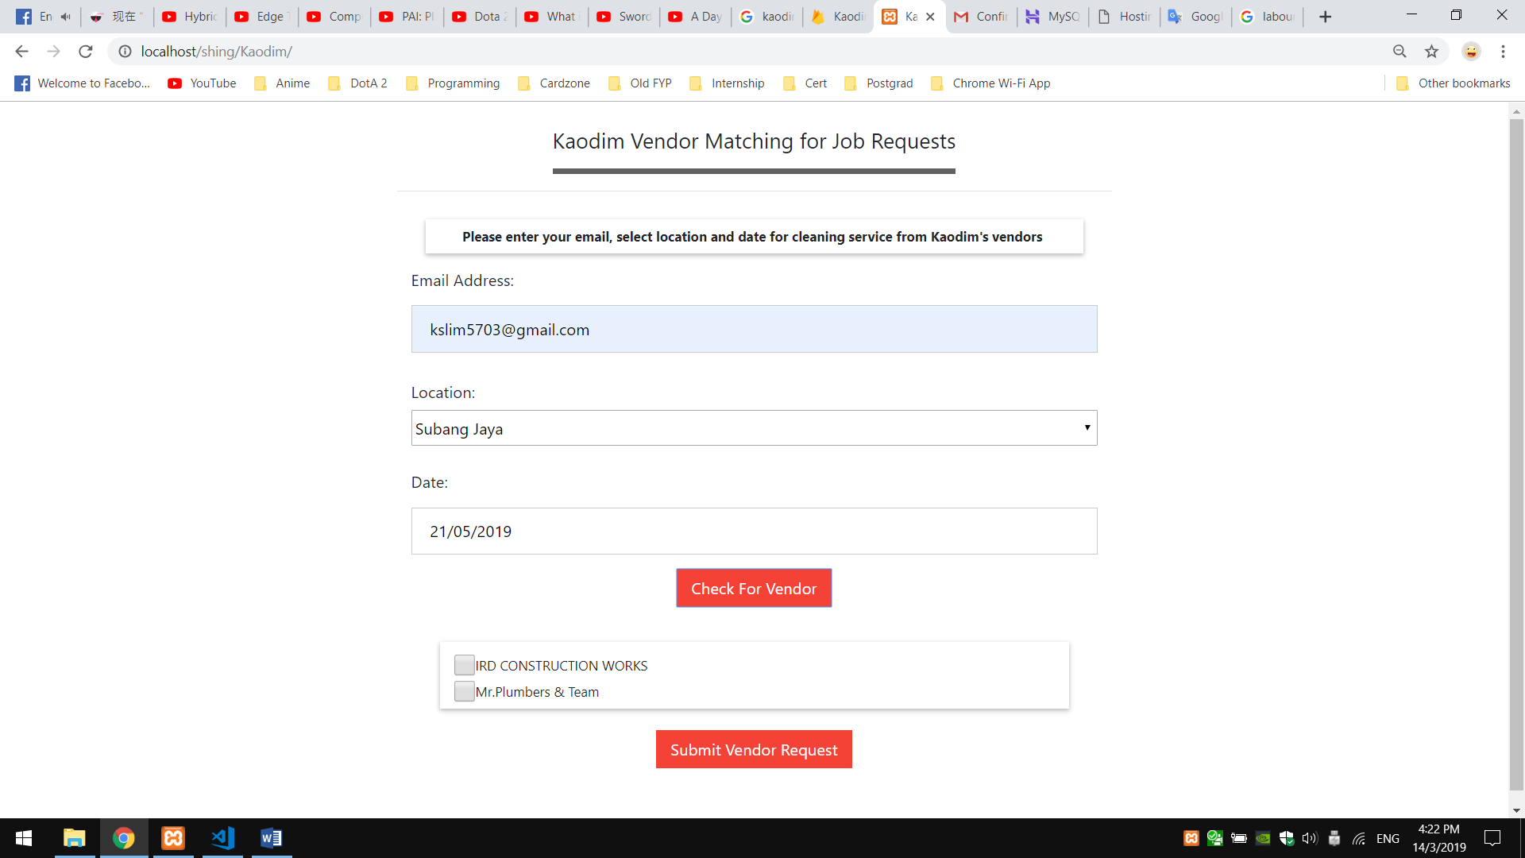

Figure 6: More vendors available

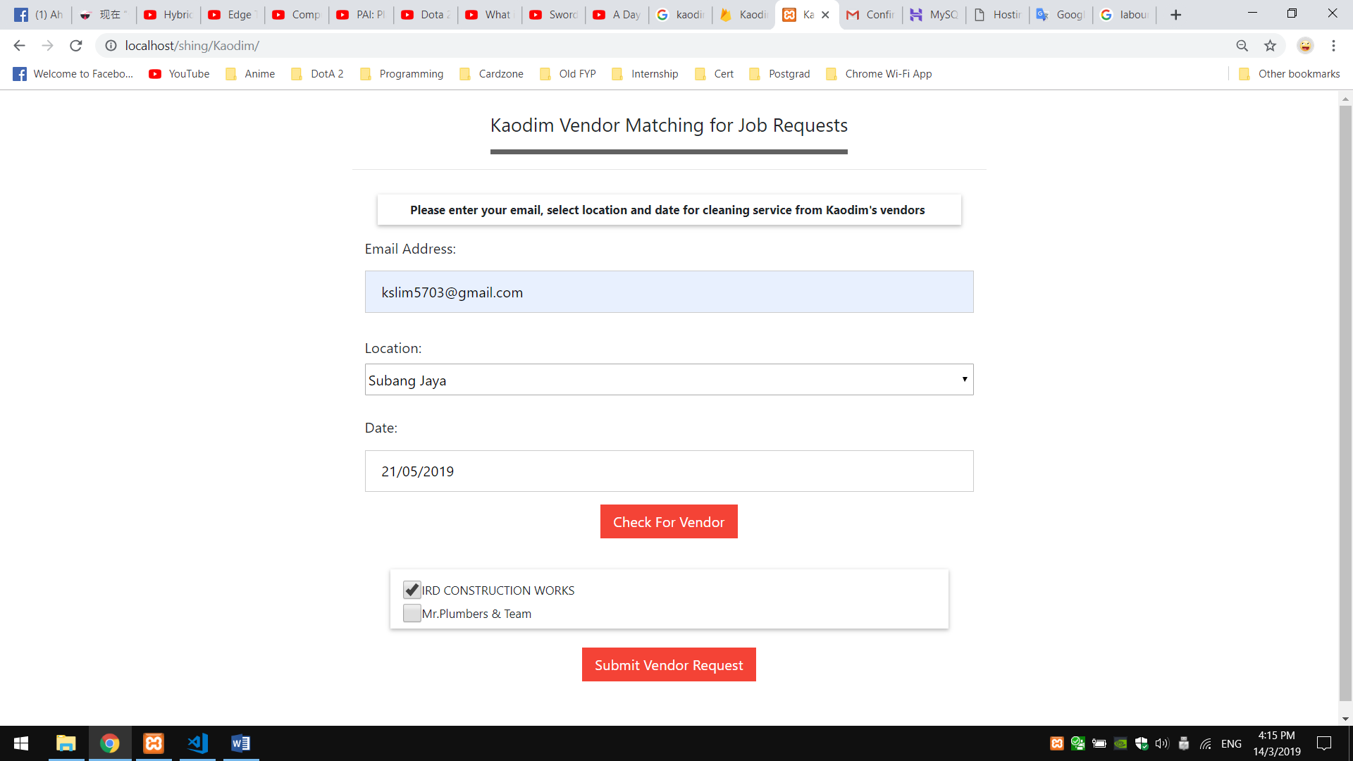

Figure 7: Select vendor and click <Submit Vendor Request>

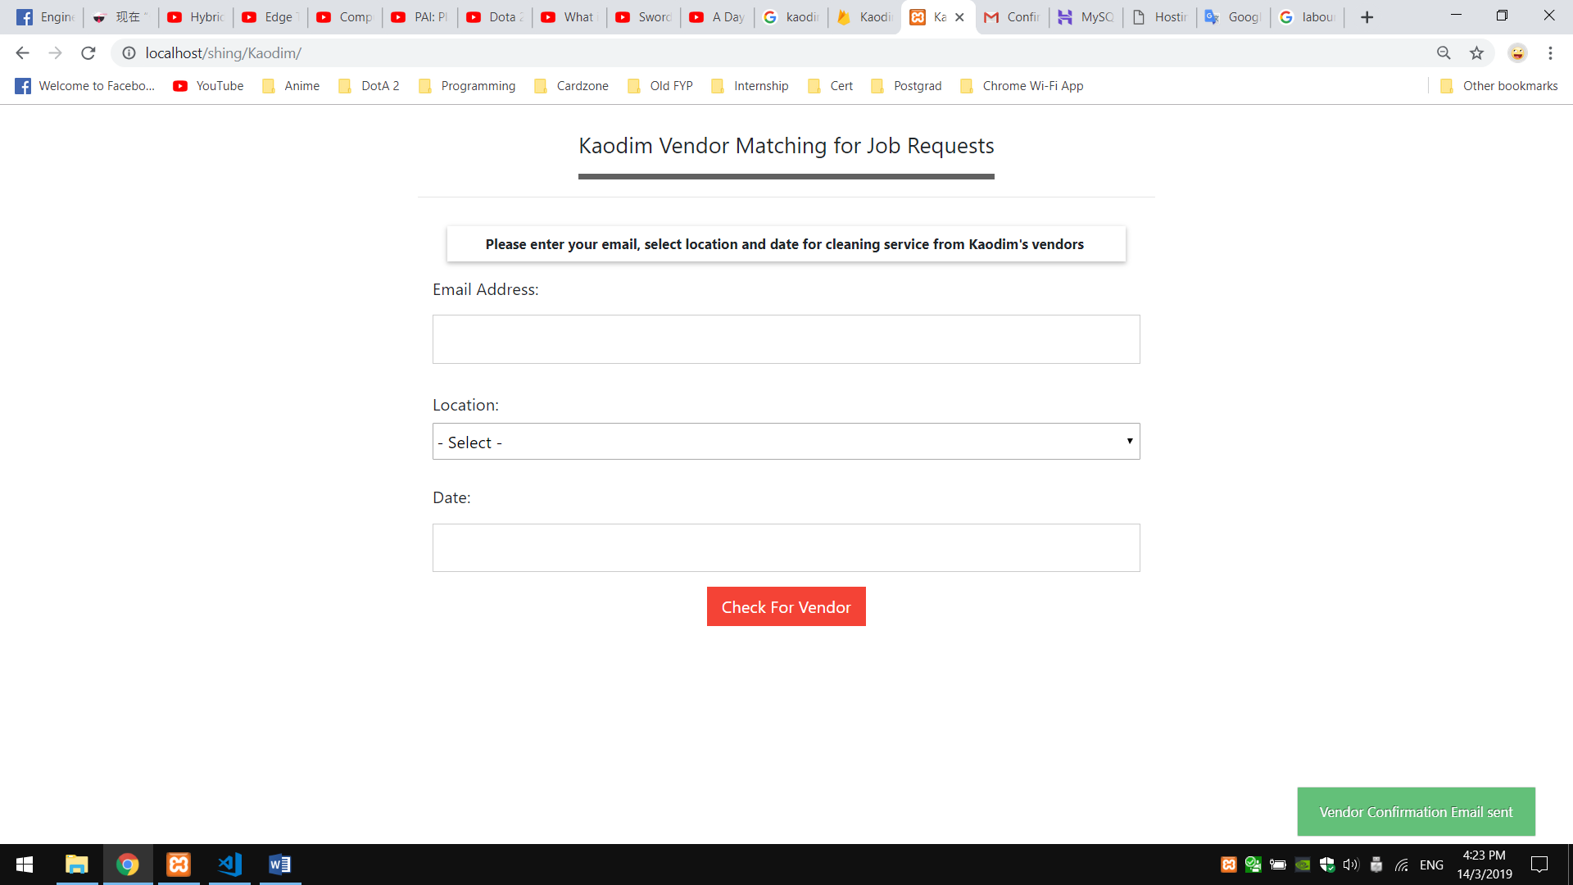

Figure 8: A confirmation email will send to the email address.

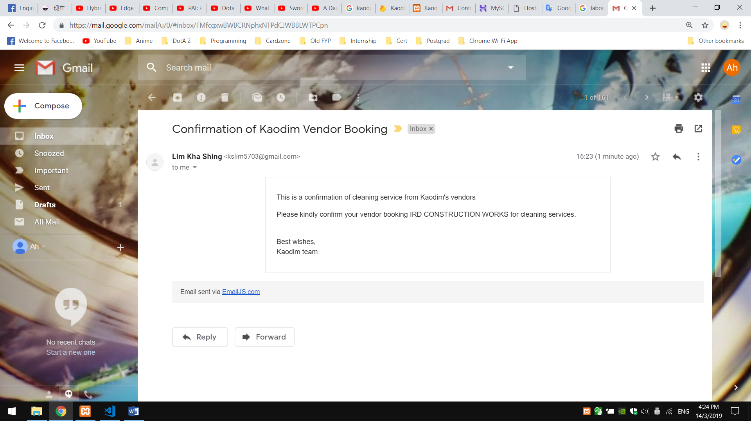

Figure 9: Received email